

**ENCLOSURE & PCB**

**RESOURCES**

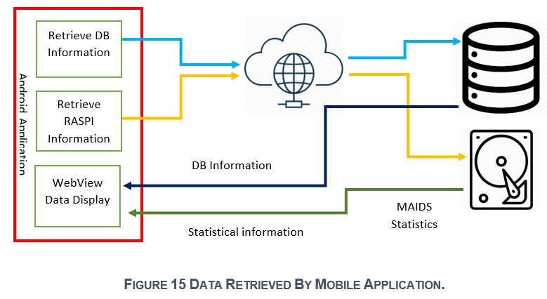 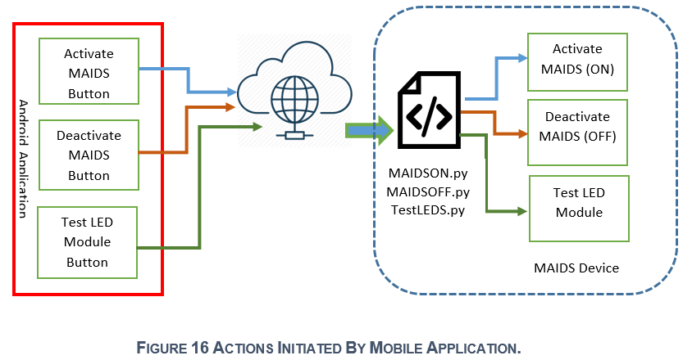 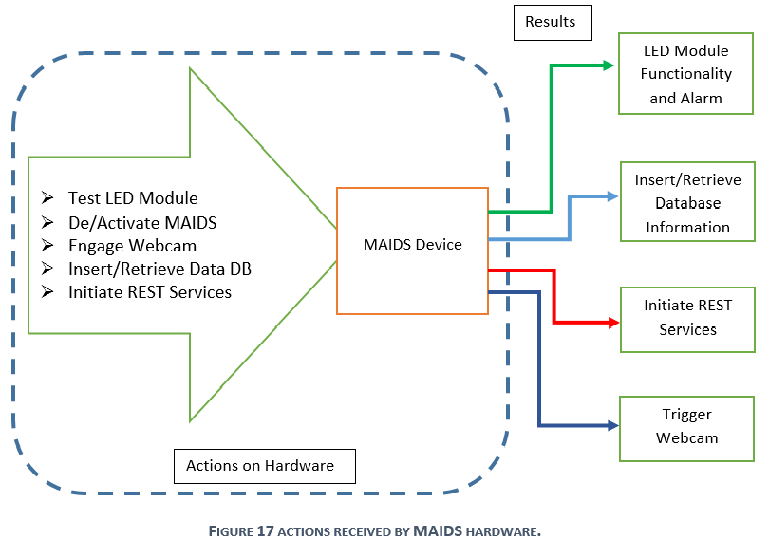



**INTRODUCTION**

**Claudio F. Meis – N00674230 - Humber College – Computer Engineering Program – CENG355 – April 2020**

**c**

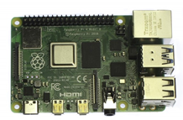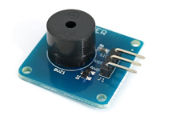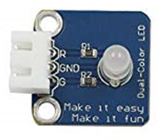

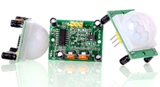

**HC Prototyping Lab**

**Break-ins occur every 90 seconds in Canada!**



**MAIDSS (Meis Alarm Intrusion Detection System) is a real-world IoT distributed system alarm project providing multi-channel alerts and remote Android application control during an intrusion event.**

**HUMBER COLLEGE**

**Reference: MAIDS Capstone Project Report**

* **Surveillance Capabilities**
* **Multi-channel Alerts**
* **Motion & Sound Detection**
* **Visual Capabilities**
* **Signal Processing Circuitry**
* **Android Tablet Remote Control**
* **Secure Interaction (SSH)**
* **Web-Based Intrusion Database**

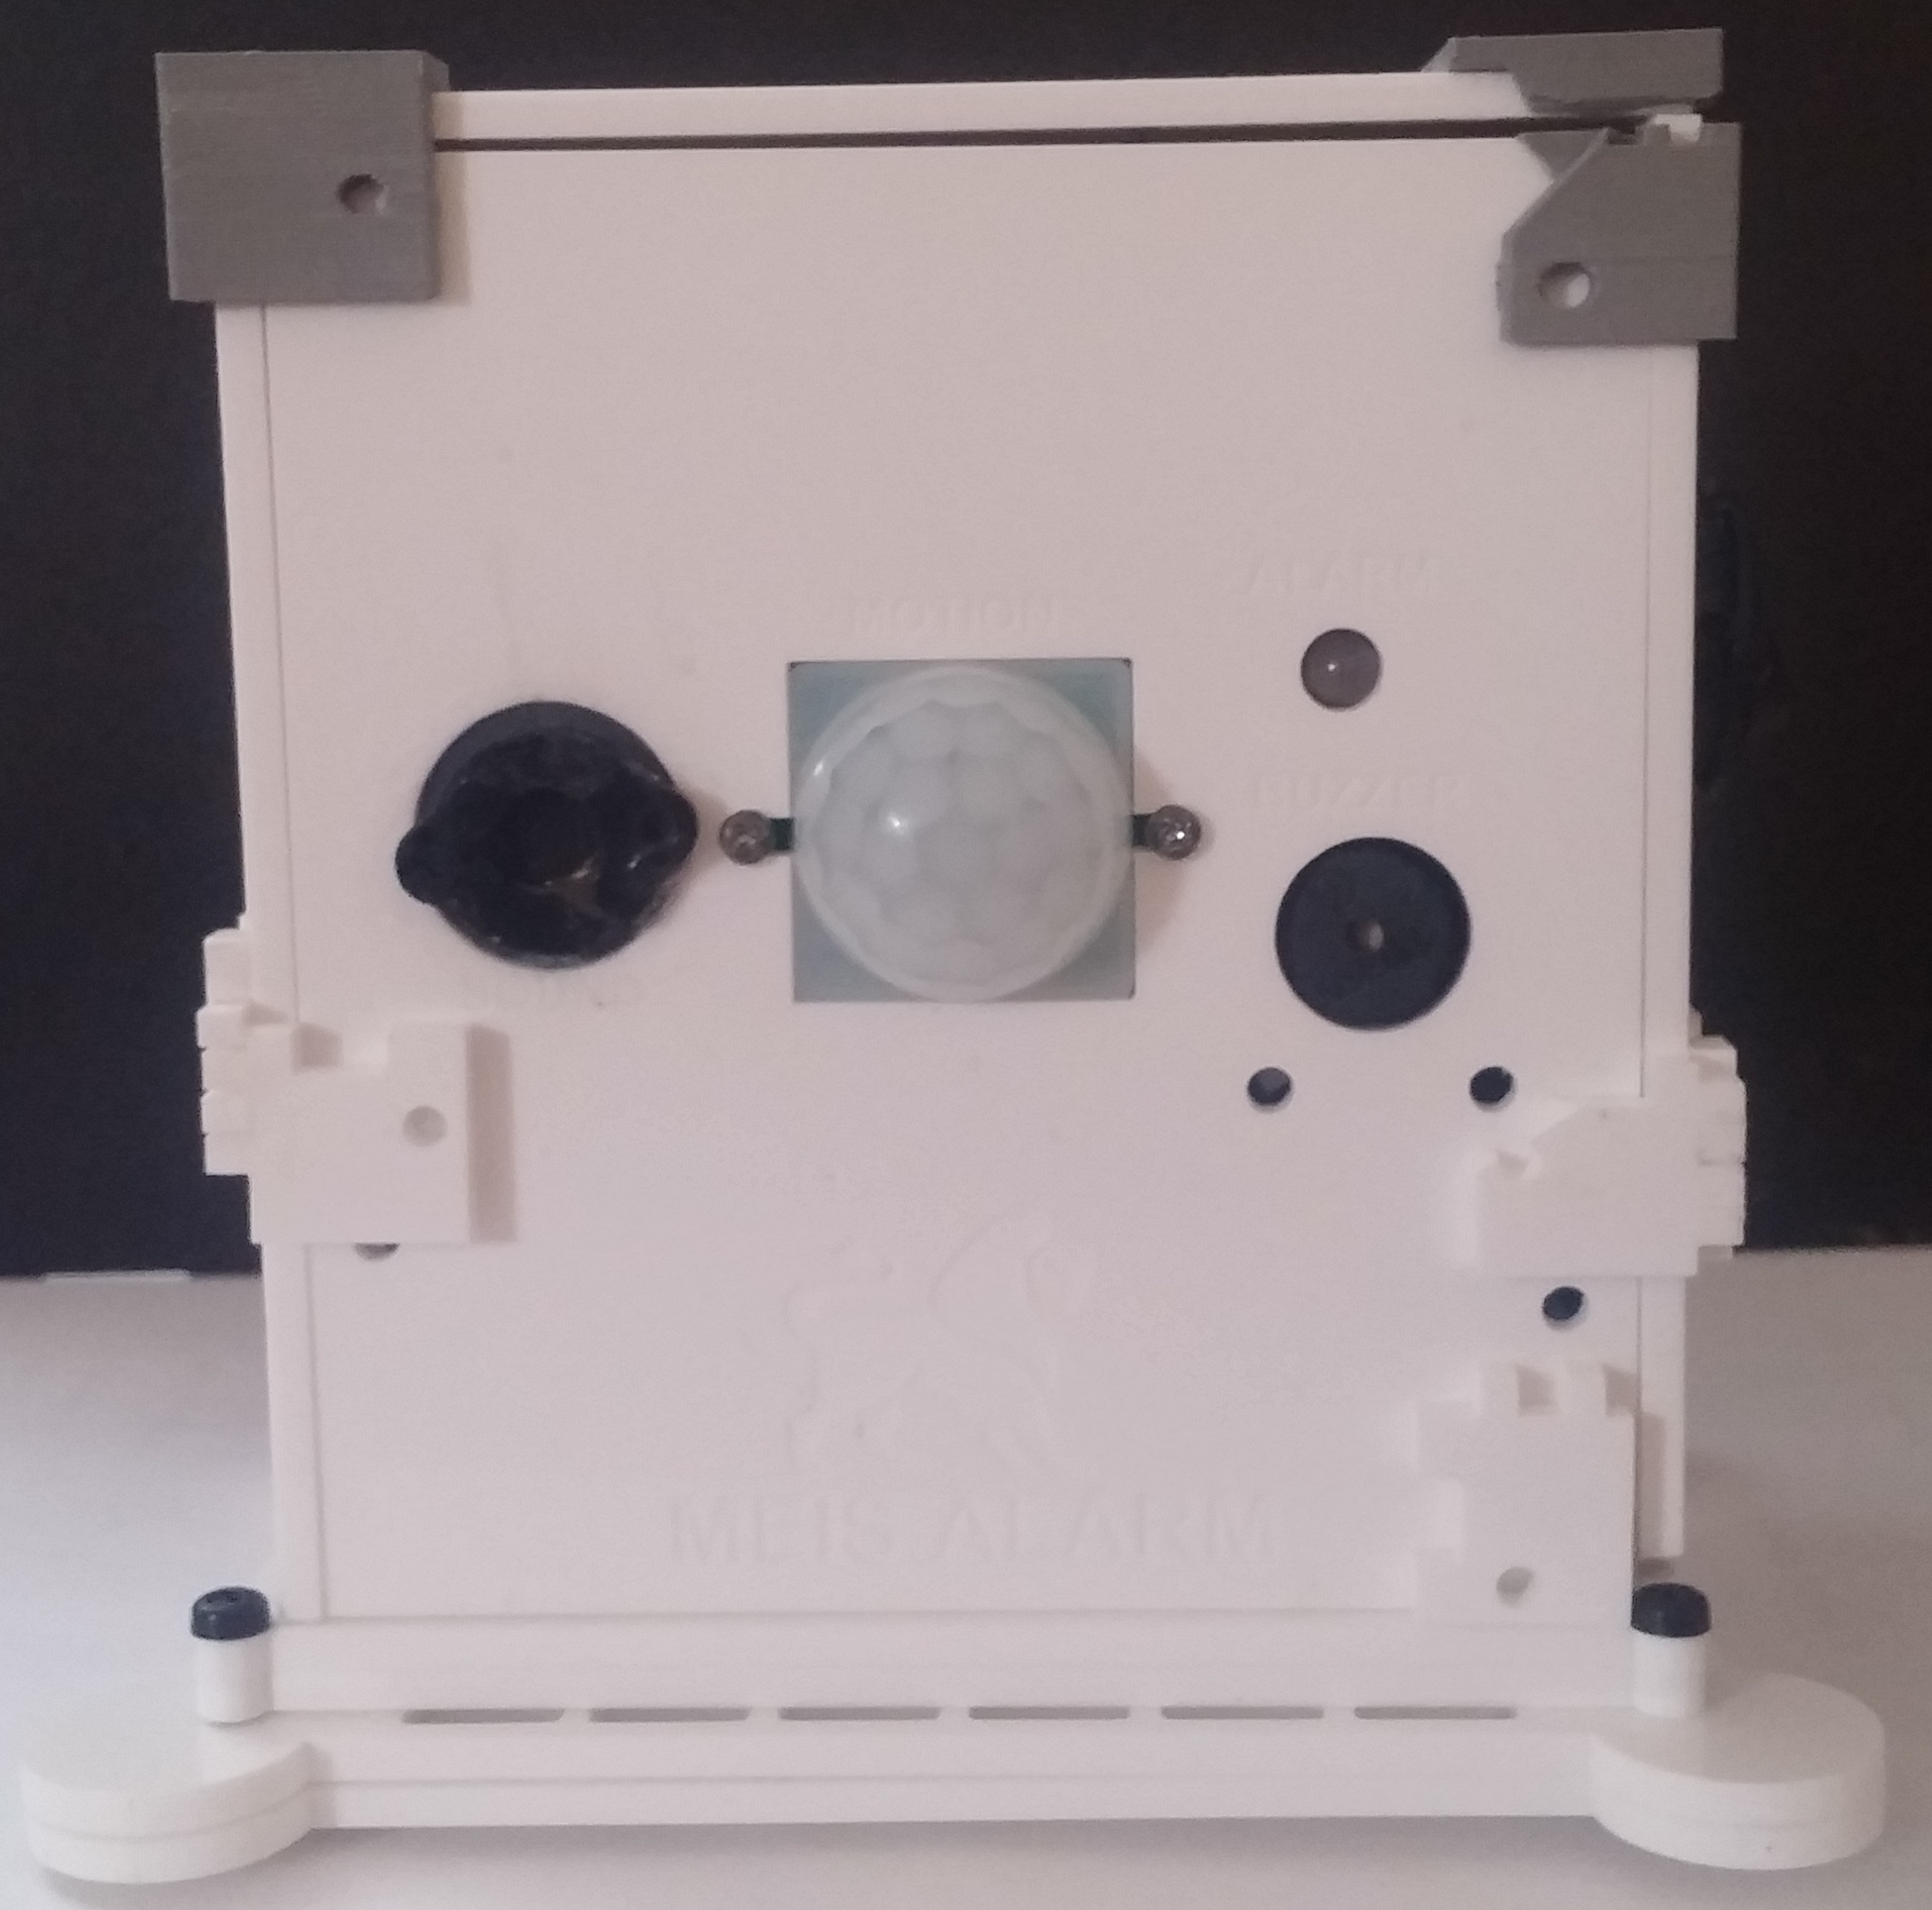 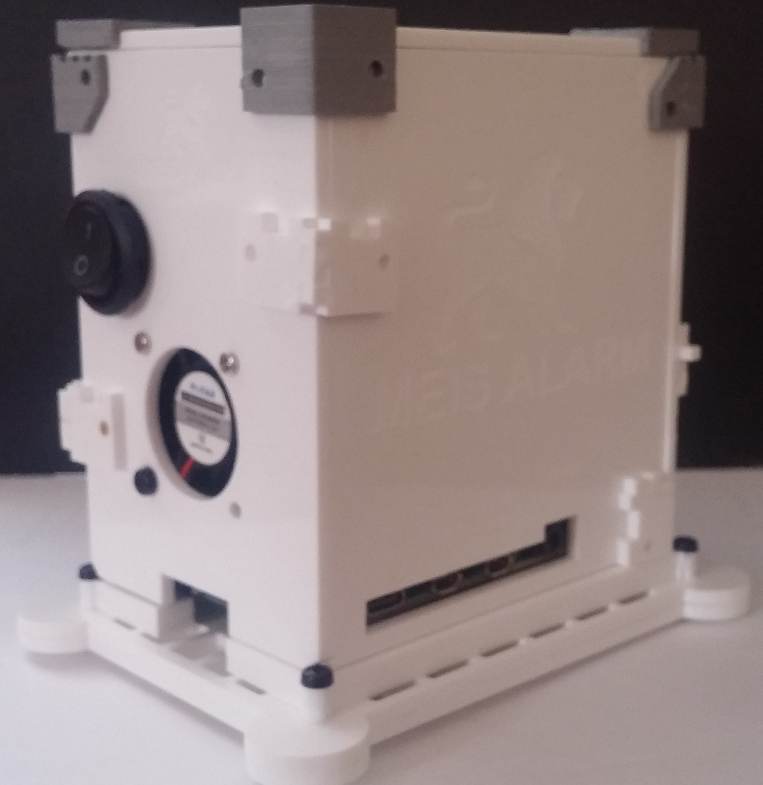

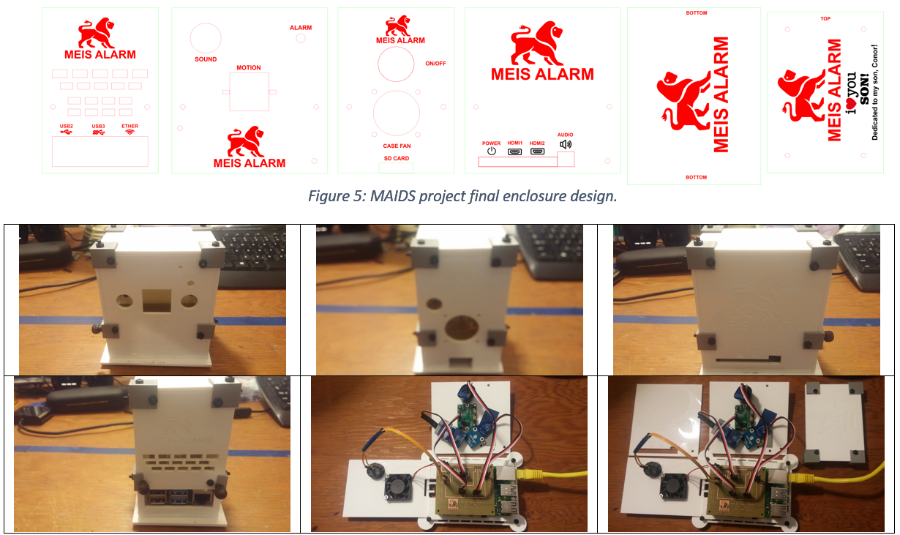

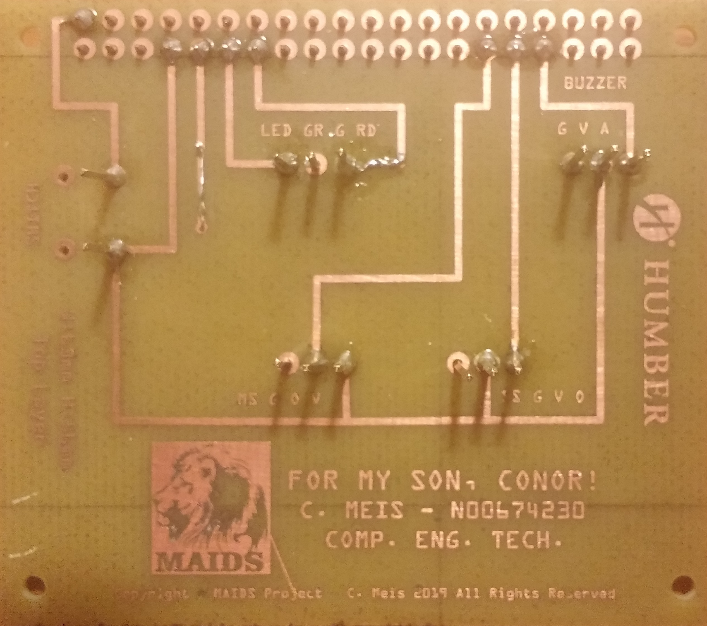

**MOBILE APPLICATION AND DATABASE INTERACTION**

**ELECTRONICS & FIRMWARE INTERACTION**

**CONCLUSIONS**

